APPLICATION FORM
Valid for Call 2 ‘Calls for Partners’
March 2014
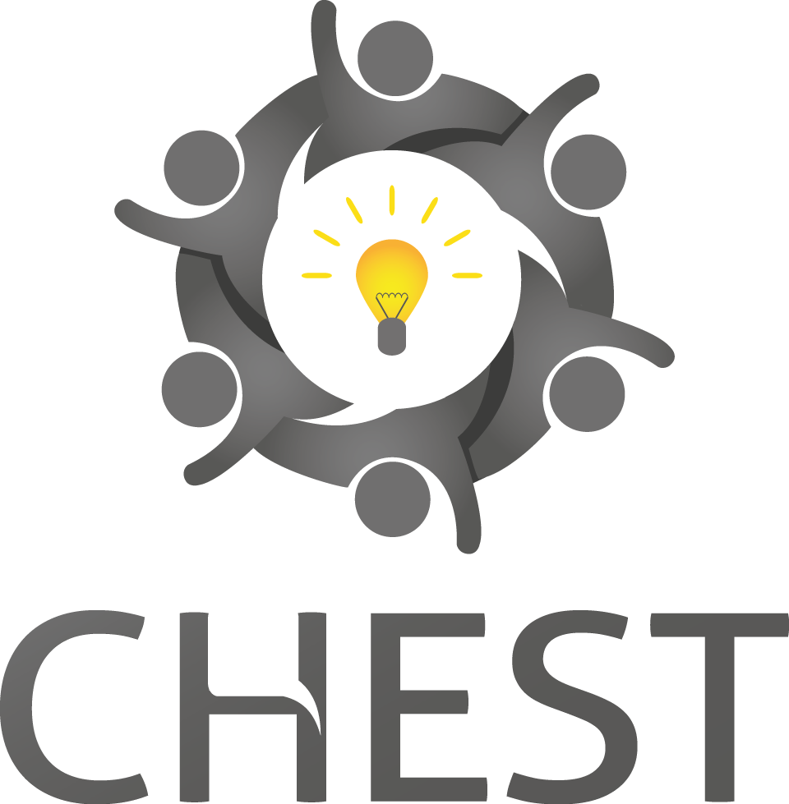

Valid for Call 2 ‘Call for Partners’ of the CHEST project, which is supported by the Seventh Framework programme of the European Commission
Categories of societal challenges | Select the category(s) that best describes the societal challenge. Knowledge Society and Education  Social Inclusion, Human Rights and Equality  Civic Empowerment and Community Engagement  Environment and Sustainability  Health and Demographic Change  Economic Empowerment and Prosperity  Other  If ‘Other’, please describe (max 100 characters)
Categories of digital solutions | Select the category(s) that best describes the digital aspect of the project. Social Software  Open Source  Physical Computing  Geolocation  Web/Internet  Audiovisual  Data  Mobile  Other
Project title
(max 50 characters)

Project outline
(max 1500 characters).

This will be public.

Project Start Date
(No earlier than 01/11/14)

Project End Date
(No later than 31/12/15)

Project Location & Country

Name of the applicant’s organisation (if applicable)

Name of the person responsible for the application

Full postal address

Postcode

Country

Telephone Number

Email Address

Number of staff in organisation, including Directors
(if applicable)

Organisation Type | Choose an item.
Please provide your most recent turnover figure from annual accounts and the date of those accounts
(if applicable)

Organisation Legal Status
(if applicable)

How did you hear about the CHEST Competition?

Part B
Section 1: Excellence
You should complete the following four questions related to the Scientific and Technical Excellence of your project. The scores are equally weighted.

Challenge Description
(max 3000 characters)

Project Objectives
(max 3000 characters)

Project Maturity
(max 2000 characters)

Innovation
(max 3000 characters)

Section 2: Impact

You should complete the following three questions related to the potential impact of your idea. The scores are equally weighted.

Target Group
(max 3000 characters)

Potential Impact
(max 3000 characters)

Route to Market
(max 3000 characters)

Section 3: Implementation

You should complete the following three questions related to the potential impact of your project. The scores are equally weighted

Project Plan
(max 4000 characters)

E.g.
WP1 Overview:
WP1 Timing:
WP1 Deliverable:
WP1 Risks:
Applicant Competences
(max 2000 characters)

Financial Costs

Budget Table

Item |  | Total Cost (EUR)
Personnel
Other Direct
Travel & Subsistence
Materials/ Consumables
Equipment
Total Direct Costs |  | 0.00
Indirect – Choose your rate:  Large Industry – 20%  Other – 60% |  | 0.00
Subcontractor
Total Project Costs |  | 0.00
Requested Contribution – Choose your rate:  Large Industry – 50%  Other – 75% |  | 0.00
Double click ‘Update Fields’ to ensure all figures are correct.

Justification of Resources
Finance Details
(max 3000 characters)

Personnel
For each post:
Role in project
Gross annual cost
Number of days on project

Other Direct Costs
Detail the consumables, travel and accommodation and equipment costs of your project, explaining why they are needed.

Subcontracting
Detail the work that will be subcontracted, how much it will cost, why it is needed and, if known, who will be doing the work.

Appendices
Two additional sides of A4 to support your application (optional).

